SIMATS ENGINEERING (SAVEETHA SCHOOL OF ENGINEERING)
Department of Computer Science and Engineering

ASSESSMENT TOOL 2 – CONCEPT MAPPING

Course Code: | CSA06 | Course Title: | Design and Analysis of Algorithms
CO Assessed: | CO1 – Precision (BL1, BL2, BL3) | Assessment: | Assessment Tool 2 – Concept Mapping
Weightage: | 20% of CIA | Total Marks: | 100 (2 Questions × 50 Marks)
CO1 Statement: | Determine algorithm efficiency using asymptotic notations and mathematical techniques including Master Theorem and substitution method. (BL1, BL2, BL3)
Student Name: | Lella Thannveer Reddy | Reg. No.: | 192524293
Section / Batch: | Slot-A | Date: | 18/07/2026

Instructions to Students
- Answer BOTH questions. Each question carries 50 Marks. Total: 100 Marks.
- Draw a clear and neat concept map for each question.
- Identify all key concepts and arrange them in a logical hierarchy.
- Show meaningful linkages between concepts using arrows and connecting words.
- Compare related concepts wherever required and justify the relationships clearly.
- Ensure the concept map is well-organized, readable, and properly labelled.

Question Type | Focus Area | Questions | Marks
Concept Mapping | Map algorithm efficiency concepts using asymptotic analysis, search techniques, recurrence relations, and recursion tree method | Q1 – Q2 | Q1 –50 Q2 –50
 | GRAND TOTAL: | 100 Marks

SECTION A – CONCEPT MAPPING
Q1. Consider the concept map: Algorithm → Growth Function → Big-Omega → Lower Bound → Best-case Explain how lower bound represents minimum execution time. Extend the map with performance guarantee node. Justify why best-case analysis is useful. Interpret how this contributes to overall performance understanding.

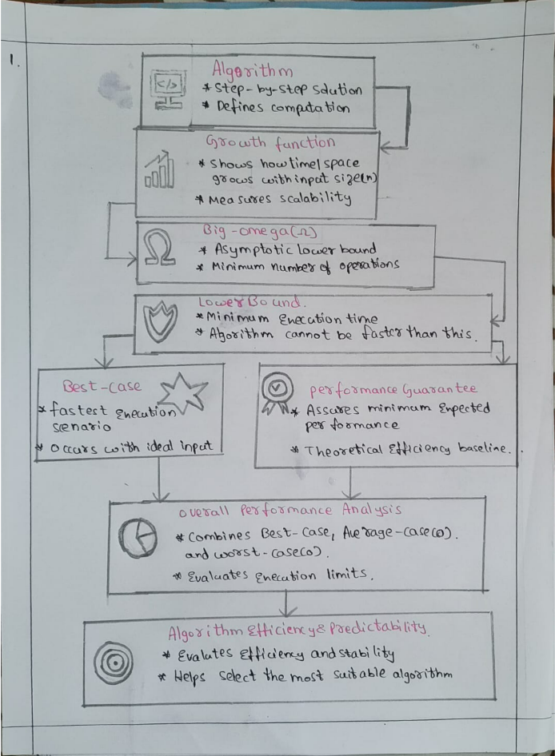
Q2. Consider the concept map: Recurrence Relation → Substitution Method → Expansion → Simplification → Final Complexity Trace the step-by-step transformation of recurrence into a closed form. Extend the map with Guess and Verification nodes. Justify how substitution helps solve non-standard recurrences. Interpret how this structured approach improves understanding.

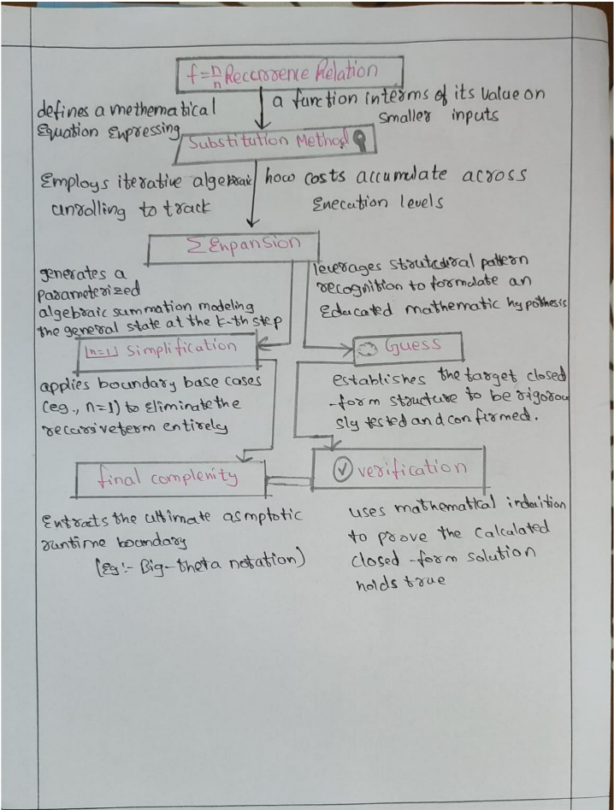

Code of Conduct
I Lella Thannveer Reddy/(192524293) (Name / Reg No) certify that this submission is my original work and that I have adhered to the guidelines specified for this assessment. I understand that any violation of academic integrity rules will result in disciplinary action.
Signature of the Student: _Lella Thannveer Reddy_

RUBRICS FOR CALCULATION

Criteria | Weighta ge | Level 4 –  Exemplary | Level 3 –  Proficient | Level 2 –  Developing | Level 1 –  Beginning
Concept  Identification | 25% | Identifies all key concepts from  literature accurately and comprehensively | Identifies most key concepts with minor omissions | Identifies limited concepts; some are irrelevant or missing | Fails to identify essential concepts
Linkages | 25% | Establishes clear, meaningful, and accurate relationships between concepts | Shows correct relationships with minor gaps | Relationships are weak, unclear, or partially incorrect | No meaningful relationships established
Organization | 20% | Concepts are well-structured hierarchically with logical flow and grouping | Mostly organized with minor structural issues | Some organization but lacks clear hierarchy | No logical organization or structure
Integration of Literature | 20% | Integrates multiple studies effectively to show connections and comparisons | Shows some integration of literature | Limited integration; mostly isolated concepts | No integration  of literature evidence
Clarity | 10% | Concept map is  clear, neat, visually structured, and easy to interpret | Generally clear with minor readability issues | Clarity is reduced; difficult to interpret in parts | Poorly presented and hard to understand
Marks Evaluation:
Questio n No. | Concept  Identification  (25%) | Linkages (25%) | Organizatio n (20%) | Integratio n of  Literature  (20%) | Clarity (10%) | Total Marks (Each – 50)
Q1
Q2
 |  |  |  | Overall Total (100)

Faculty In-charge | Course Coordinator | Head of Department
Dr G Nagarajan
Signature: _______________ | Signature: _______________ | Signature: _______________
Date: ___________________ | Date: ___________________ | Date: ___________________

